Algorithmic Performance and Fairness of Machine Learning Models for Dementia Classification Using the Harmonized Cognitive Assessment Protocol (HCAP)

Jiao Yu, PhD, Xi Chen, PhD

Yale School of Public Health

Key Points

Question : Do algorithms trained on clinically validated dementia classifications from a nationally representative older adult cohort perform accurately and equitably across sociodemographic subgroups?
Findings : In this study of 3,494 older adults, all six algorithms achieved high accuracy (0.83–0.91) and sensitivity (0.81–0.93) for dementia classification. Fairness analyses revealed meaningful performance disparities across racial/ethnic groups and by sex, with Hispanic and male participants showing systematically lower equal opportunity and predictive equality in several models.
Meaning : While machine learning models demonstrate strong overall discriminative performance for dementia classification, algorithmic predictions are not equitable across sociodemographic subgroups. Deployment of these models in clinical or research settings without fairness evaluation risks magnifying existing health disparities.

Abstract

Importance : Algorithmic dementia classification is increasingly used in large-scale epidemiological research. However, most existing algorithms were developed using earlier cohorts and have rarely been evaluated for fairness across sociodemographic subgroups. Inequitable model performance risks amplifying existing health disparities.
Objective : To evaluate predictive performance and algorithmic fairness of six algorithms for dementia classification using a clinically validated, nationally representative cohort of older Americans.

Design, Setting, and Participants : This cross-sectional study used 3,494 Americans aged 65 years or older from the 2016 Health and Retirement Study Harmonized Cognitive Assessment Protocol (HRS-HCAP), a nationally representative study that used a comprehensive in-person neuropsychological battery and clinician-validated dementia classifications. Data were analyzed from January 9, 2026 to May 5, 2026.
Main Outcomes and Measures : We compared performance across six algorithms, including logistic regression, LASSO, random forest (RF), support vector machine (SVM), XGBoost, and Super Learner. Predictors included neuropsychological test scores, sociodemographic characteristics, health status, health behaviors, and childhood geographic factors. Model performance was assessed using accuracy, sensitivity, and specificity. Algorithmic fairness was quantified across race/ethnicity, sex, age, and education using equal opportunity, predictive equality, and equalized odds, with absolute gaps exceeding 0.10 considered meaningful disparities.
Results : Among 3,494 participants, 418 (12.0%) had dementia. The sample was 71.1% White, 15.7% Black, and 10.9% Hispanic, with a mean age of 76.5 years (SD 7.6) and 60.0% women. All six models achieved high overall accuracy (0.83–0.91), sensitivity (0.81–0.93), and specificity (0.82–0.93). Compared with widely used existing HRS dementia algorithms, these models demonstrated substantially improved case detection. Fairness analyses identified meaningful disparities across racial and ethnic groups and sex, indicating that Hispanic participants and male participants were more likely to have dementia cases missed by the algorithms.
Conclusions and Relevance : Dementia classification algorithms, especially machine learning models, demonstrated strong overall predictive performance but exhibited meaningful fairness disparities across racial, ethnic, and sex subgroups. These findings underscore that algorithms performing well on aggregate metrics may produce inequitable predictions for demographic subgroups, potentially magnifying disparities in dementia detection.

Table 1 Characteristics of Study Participants, HRS-HCAP 2016
 | Overall | Normal | Dementia | p
n | 3494 | 3076 | 418
Female (%) | 2095 (60.0) | 1841 (59.9) | 254 (60.8) | 0.76
White (%) | 2482 (71.1) | 2201 (71.6) | 281 (67.2) | 0.071
Black (%) | 548 (15.7) | 479 (15.6) | 69 (16.5) | 0.679
Hispanic (%) | 382 (10.9) | 325 (10.6) | 57 (13.6) | 0.072
Other (%) | 79 (2.3) | 68 (2.2) | 11 (2.6) | 0.715
Age (mean (SD)) | 76.47 (7.60) | 75.76 (7.31) | 81.64 (7.72) | <0.001
Less than high school (%) | 653 (18.7) | 531 (17.3) | 122 (29.2) | <0.001
Born in the South | 1174 (33.6) | 1,001 (32.6) | 173 (41.4) | <0.001
High blood pressure (%) | 2676 (76.6) | 2338 (76.0) | 338 (80.9) | 0.033
Diabetes (%) | 1191 (34.1) | 1048 (34.1) | 143 (34.2) | 0.999
Ever smoke (%) | 1911 (54.7) | 1676 (54.5) | 235 (56.2) | 0.538
Excessive drinking (%) | 357 (10.2) | 338 (11.0) | 19 (4.6) | <0.001
Obesity (%) | 1068 (30.9) | 981 (32.1) | 87 (21.6) | <0.001
Physical exercise (mean (SD)) | 18.90 (14.81) | 20.17 (14.71) | 9.41 (11.80) | <0.001
CES-D (mean (SD)) | 1.38 (1.90) | 1.29 (1.82) | 2.18 (2.34) | <0.001
Self-rated eyesight (%) |  |  |  | <0.001
Excellent | 236 (6.8) | 213 (7.0) | 23 (5.6)
Very good | 865 (24.9) | 792 (25.9) | 73 (17.7)
Good | 1472 (42.4) | 1337 (43.7) | 135 (32.8)
Fair | 647 (18.6) | 524 (17.1) | 123 (29.9)
Poor | 250 (7.2) | 192 (6.3) | 58 (14.1)
Self-rated hearing (%) |  |  |  | <0.001
Excellent | 414 (11.9) | 367 (11.9) | 47 (11.3)
Very good | 833 (23.9) | 768 (25.0) | 65 (15.6)
Good | 1271 (36.4) | 1123 (36.5) | 148 (35.6)
Fair | 696 (19.9) | 601 (19.6) | 95 (22.8)
Poor | 275 (7.9) | 214 (7.0) | 61 (14.7)
Social isolation (%) | 820 (24.4) | 711 (23.9) | 109 (27.8) | 0.108
IADL (mean (SD)) | 0.49 (1.13) | 0.30 (0.81) | 1.88 (1.93) | <0.001
ADL (mean (SD)) | 0.59 (1.33) | 0.44 (1.09) | 1.73 (2.16) | <0.001
Self-rated health (%) |  |  |  | <0.001
Very poor | 227 (6.5) | 209 (6.8) | 18 (4.3)
Poor | 928 (26.6) | 884 (28.7) | 44 (10.6)
Average | 1219 (34.9) | 1086 (35.3) | 133 (31.9)
Good | 836 (23.9) | 704 (22.9) | 132 (31.7)
Excellent | 282 (8.1) | 192 (6.2) | 90 (21.6)
Stroke (%) | 447 (12.8) | 326 (10.6) | 121 (28.9) | <0.001
Heart disease (%) | 1193 (34.1) | 1026 (33.4) | 167 (40.0) | 0.009
Social security income quantile |  |  |  | 0.545
1 | 273 (7.8) | 239 (7.8) | 34 (8.1)
2 | 272 (7.8) | 237 (7.7) | 35 (8.4)
3 | 1387 (39.7) | 1211 (39.4) | 176 (42.1)
4 | 1562 (44.7) | 1389 (45.2) | 173 (41.4)
Retirement (%) | 3088 (92.0) | 2707 (91.3) | 381 (96.9) | <0.001
Not married (%) | 1561 (44.7) | 1311 (42.6) | 250 (60.0) | <0.001
Change of cognition(TICS) | -0.63 (3.55) | -0.55 (3.54) | -1.45 (3.56) | <0.001
Change of IADL | 0.13 (0.82) | 0.06 (0.64) | 0.70 (1.54) | <0.001
Change of ADL | 0.14 (0.97) | 0.07 (0.82) | 0.65 (1.63) | <0.001
Change of self-rated health | 0.11 (0.84) | 0.09 (0.81) | 0.27 (1.02) | <0.001
Memory score (mean (SD)) | 46.77 (11.79) | 48.79 (10.39) | 31.94 (10.84) | <0.001
Executive function score (mean (SD)) | 46.01 (11.77) | 47.89 (10.36) | 32.19 (12.35) | <0.001
Language and fluency score (mean (SD)) | 47.69 (11.04) | 49.07 (10.27) | 37.54 (11.18) | <0.001
Visuospatial score (mean (SD)) | 47.58 (11.39) | 48.95 (10.37) | 37.46 (13.33) | <0.001
Orientation score (mean (SD)) | 9.25 (1.41) | 9.57 (0.80) | 6.96 (2.43) | <0.001

Table 2 Performance Metrics in the Testing Data
 | Accuracy | 95% CI | Sensitivity | 95% CI | Specificity | 95% CI
LOGISTIC | 0.91 | [0.88, 0.94] | 0.81 | [0.68, 0.91] | 0.93 | [0.89, 0.95]
LASSO | 0.91 | [0.88, 0.94] | 0.81 | [0.68, 0.91] | 0.93 | [0.89, 0.95]
RF | 0.91 | [0.88, 0.94] | 0.83 | [0.72, 0.94] | 0.92 | [0.88, 0.95]
SVM | 0.90 | [0.87, 0.93] | 0.81 | [0.69, 0.92] | 0.91 | [0.88, 0.94]
XGBOOST | 0.83 | [0.79, 0.87] | 0.93 | [0.84, 1.00] | 0.82 | [0.77, 0.86]
SUPERLEARNER | 0.87 | [0.83, 0.90] | 0.88 | [0.78, 0.97] | 0.87 | [0.83, 0.90]

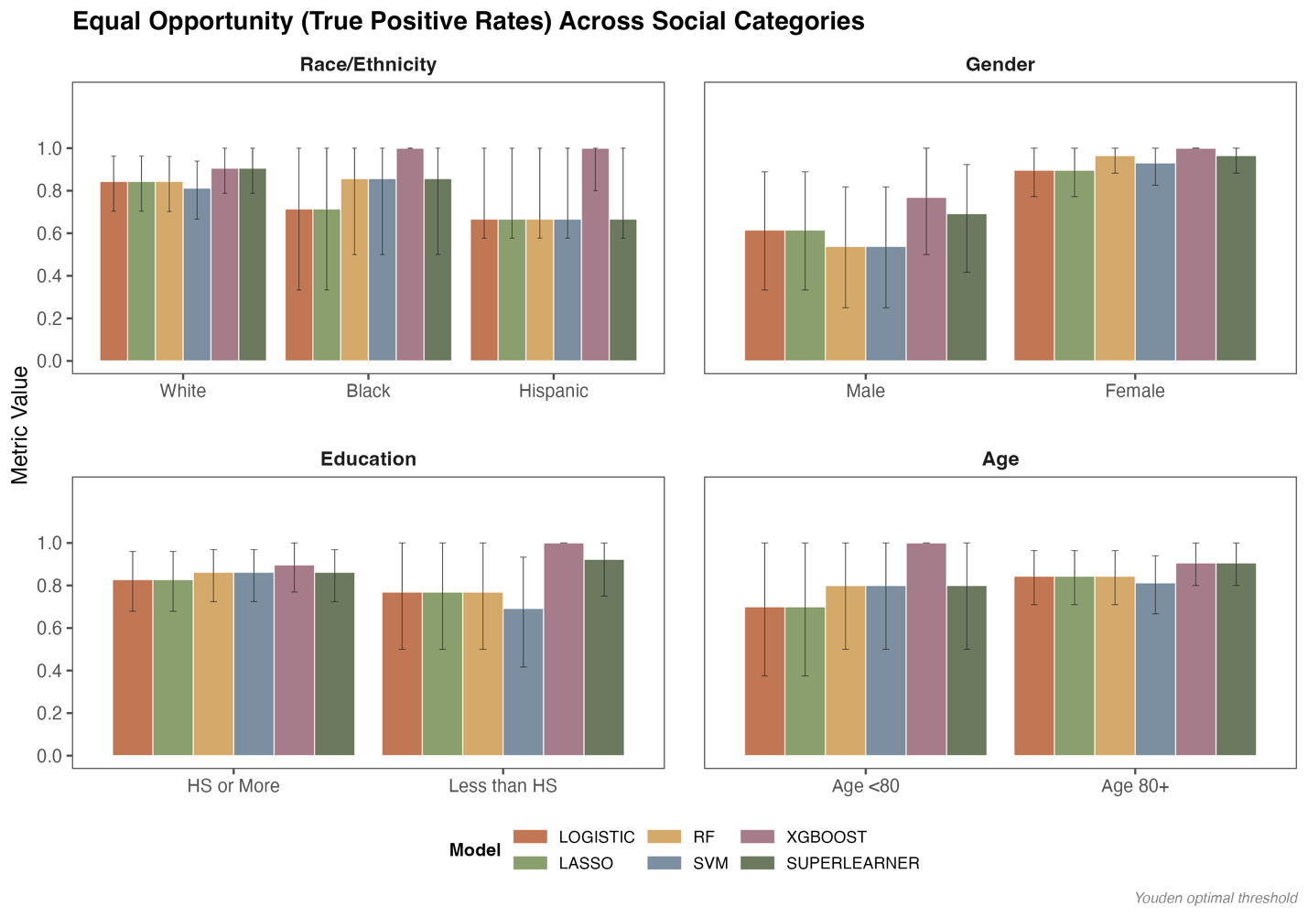
Figure 1 Equal Opportunity (True Positive Rates) Across Social Categories

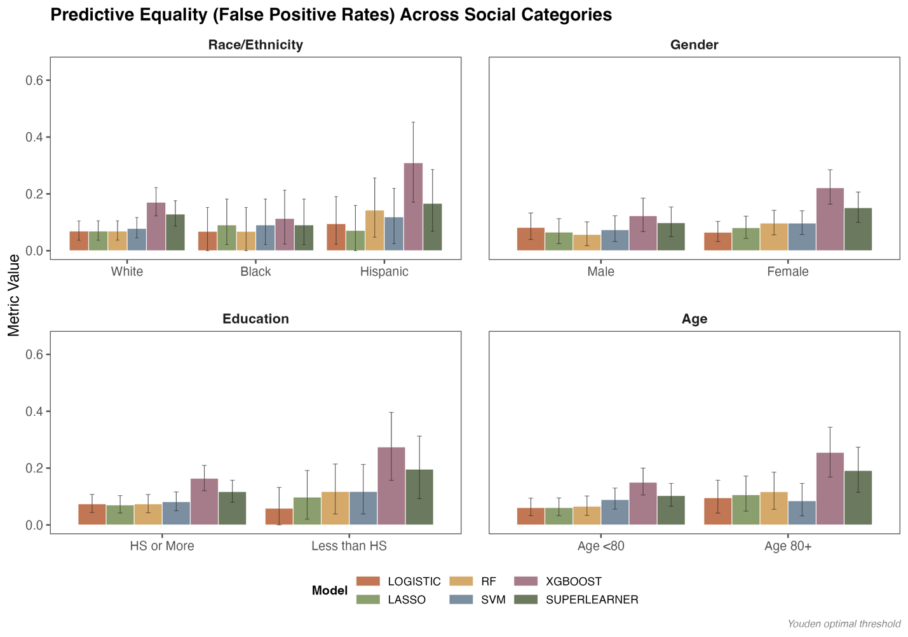
Figure 2 Predictive Equality (False Positive Rates) Across Social Categories

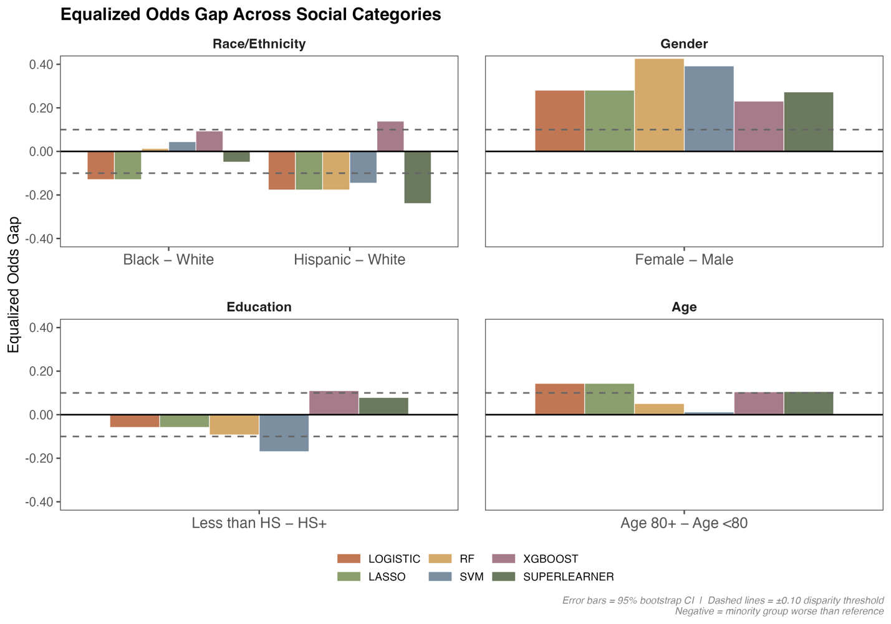
Figure 3 Equalized Odds Gap Across Social Categories
Note: Equalized Odds requires both the true positive rate and false positive rate to be equal across demographic groups simultaneously. For the Equalized Odds analysis, we report the dominant violation, defined as the larger of the TPR gap and FPR gap between groups, to illustrate equalized Odds disparity.
Dashed lines indicate the ±0.10 fairness disparity threshold. Gaps exceeding this threshold are considered meaningful performance disparities across subgroups.

Appendix

Table S1 Predictors Used to Classify Dementia Status of HRS Participants in Each Algorithm
Predictor Variables | Langa -Weir (2009) | Crimmins (2011) | Hurd (2013) | Gianattasio-Power (2020) | Hudomiet (2022) | Livingston et al. (2024)ª | Our Study
Cognitive test
Memory | X | X | X | X | X |  | X
Orientation |  | X | X | X | X |  | X
Executive function | X | X | X | X | X |  | X
Language and fluency |  | X | X | X | X |  | X
Visuospatial function |  |  |  |  |  |  | X
Sociodemographic
Age |  | X | X | X | X |  | X
Gender / Sex |  | X | X | X | X |  | X
Race / Ethnicity |  |  |  | X | X |  | X
Education |  | X | X | X | X | X | X
Proxy indicator |  |  |  | X | X
Social Security Income |  |  |  |  | X |  | X
Partnered / Married status |  |  |  | X | X |  | X
Retirement status |  |  |  | X |  |  | X
Health status
ADLs |  | X | X | X | X |  | X
IADLs |  | X | X | X | X |  | X
Self-reported health status |  |  |  | X | X |  | X
History of diabetes |  |  |  | X | X | X | X
History of high blood pressure |  |  |  | X | X | X | X
BMI / Obesity |  |  |  |  |  | X | X
Ever had a stroke |  |  |  |  | X |  | X
Heart problems |  |  |  |  | X |  | X
CESD |  |  |  |  |  | X | X
Visual problems |  |  |  |  |  | X | X
Hearing problems |  |  |  |  |  | X | X
Health behaviors
Smoking |  |  |  | X |  | X | X
Drinking |  |  |  | X |  | X | X
Physical activities |  |  |  |  |  | X | X
Social isolation/engagement |  |  |  | X |  | X | X
Change variables
Change in cognition |  |  |  |  | X |  | X
Change in ADLs and IADLs |  |  |  |  | X |  | X
Change in self-reported health status |  |  |  |  | X |  | X
Childhood factors
Born in the US South |  |  |  |  | X |  | X
ª Livingston et al. (2024) is a review report on modifiable risk factors for dementia.

Table S2 Existing Dementia Prediction Algorithms Based on ADAMS Sample
Existing algorithms | Accuracy | 95% CI | Sensitivity | 95% CI | Specificity | 95% CI
Langa -Weir (2009) ª | 0.83 | [0.79, 0.85] | 0.41 | [0.30, 0.52] | 0.89 | [0.86-0.92]
Crimmins (2011)ª | 0.79 | [0.75, 0.83] | 0.62 | [0.51, 0.73] | 0.82 | [0.78-0.86]
Hurd (2013)ª | 0.88 | [0.85, 0.91] | 0.39 | [0.28, 0.51] | 0.96 | [0.94-0.98]
Gianattasio-Power (2020)-Hurd model ^{b} | 0.92 | [0.90-0.93] | 0.79 | [0.73-0.85] | 0.94 | [0.92-0.95]
Gianattasio-Power (2020)-Expert model ^{b} | 0.90 | [0.88-0.92] | 0.77 | [0.71-0.82] | 0.93 | [0.91-0.94]
Gianattasio-Power (2020)-Lasso model ^{b} | 0.91 | [0.89-0.92] | 0.83 | [0.77-0.88] | 0.92 | [0.91-0.94]
ª Algorithm performance estimates were derived from Gianattasio et al., 2019
^{b} Algorithm performance estimates were derived from Gianattasio et al., 2020

Table S3 Definitions of 3 Fairness Metrics
Metric | Definition | Formula | What It Measures
Equal Opportunity | Sensitivity (True Positive Rate) is equal across demographic groups | TPR = TP / (TP + FN) | Of all people who truly have dementia, the proportion correctly identified by the model is the same regardless of race, gender, age, or education
Predictive Equality | False Positive Rate is equal across demographic groups | FPR = FP / (FP + TN) | Of all people who truly do not have dementia, the proportion incorrectly flagged as positive is the same across groups
Equalized Odds | Both TPR and FPR are simultaneously equal across demographic groups | EOdds gap = dominant violation of max(TPR gap, FPR gap) | The model makes equally accurate predictions for both dementia cases and non-cases across all groups — both sensitivity and false alarm rates are equal

References

Crimmins, E. M., Kim, J. K., Langa, K. M., & Weir, D. R. (2011). Assessment of cognition using surveys and neuropsychological assessment: The Health and Retirement Study and the Aging, Demographics, and Memory Study. The Journals of Gerontology: Series B, 66B(suppl_1), i162–i171. https://doi.org/10.1093/geronb/gbr048
Gianattasio, K. Z., Ciarleglio, A., & Power, M. C. (2020). Development of Algorithmic Dementia Ascertainment for Racial/Ethnic Disparities Research in the US Health and Retirement Study. Epidemiology (Cambridge, Mass.), 31(1), 126–133. https://doi.org/10.1097/EDE.0000000000001101
Gianattasio, K. Z., Ciarleglio, A., & Power, M. C. (2020). Development of Algorithmic Dementia Ascertainment for Racial/Ethnic Disparities Research in the US Health and Retirement Study. Epidemiology, 31(1), 126. https://doi.org/10.1097/EDE.0000000000001101
Gianattasio, K. Z., Wu, Q., Glymour, M. M., & Power, M. C. (2019). Comparison of Methods for Algorithmic Classification of Dementia Status in the Health and Retirement Study. Epidemiology, 30(2), 291. https://doi.org/10.1097/EDE.0000000000000945
Hurd, M. D., Martorell, P., Delavande, A., Mullen, K. J., & Langa, K. M. (2013). Monetary costs of dementia in the United States. New England Journal of Medicine, 368(14), 1326–1334. https://doi.org/10.1056/NEJMsa1204629
Langa, K. M. (2023). Langa-Weir classification of cognitive function (1995-2020). Survey Research Center Institute for Social Research University of Michigan. Https://Hrsdata. Isr. Umich. Edu/Sites/Default/Files/Documentation/Data-Descriptions/1680034270/Data_Description_Langa_Weir_Classifications2020. Pdf.
Livingston, G., Huntley, J., … Mukadam, N. (2024). Dementia prevention, intervention, and care: 2024 report of the Lancet standing Commission. The Lancet, 404(10452), 572–628. https://doi.org/10.1016/S0140-6736(24)01296-0

